2024 Fancy Feathers Egg Show
WHEN:
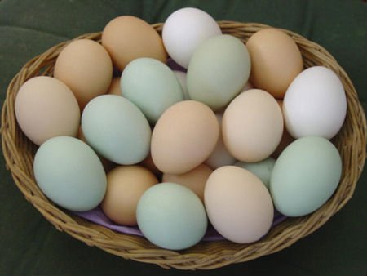
Saturday February 10th, 2024
LOCATION:
Fancy Feathers Poultry and Rabbit Show
Dripping Springs Ranch Park Events Center
1042 Event Center Dr. Dripping Springs, TX 78620

SCHEDULE:
8:30-9:30am – Registration, sign in and drop off your eggs
10:00am – LIVE Contents Judging BEGINS
11:30-12:00 – Egg show Classification Judges comments
12:00am – Champions Row

EGG CLASSES
The show features three main judging divisions, the SHELL Classes, the CONTENTS Classes and the ever imaginative DECORATING Classes. The classes are divided by color and size, including both large fowl and bantam sized eggs, with categories that anyone can enter, even if you just have one egg. Sage Talavera is our esteemed Egg Show judge and is available for questions before and after the show.
SHELL Classes are divided into White Class, Brown Class, and Colors Class, including blues, greens, olives, pinks, pastels, and tinted. The Tricolor Class requires three different colors or shades of eggs in each entry. The Single Egg Class includes single eggs from your chickens and all other kinds of poultry. If you have an odd egg, small egg, large egg, beautiful egg, this is the Class to enter.
CONTENTS Classes in both bantam and large fowl will be judged on their interior qualities. A single egg entry is cracked open and judged on the color, shape and form of the yolk and albumin, and on the freshness and visibility of the structures of the egg. Pick your freshest egg and see how it stands up to the rest!
DECORATING Classes – go wild and use your imagination. We will have two classes: a judge’s choice for single-egg best use of color, decorations, and creativity. Secondly the People’s choice for best single or multi-Egg themed (diorama) presentation. This has become a crowd favorite with highly creative use of eggs.
AWARDS
This show has with two classes: Open Adult or Youth with 12 categories. A Grand Champion, Reserve Champion and Junior Champion will be awarded at the conclusion of the show, based on cumulative points. We allow two entries per category, so the more entries you make, the additional opportunities to earn points towards the top honors. This show is part of the Georgetown 4-H and Brazos Valley Poultry Club Egg Shows, and points are added to the yearly Bluebonnet Egg show total. Lots of fun, awards, trophies and ribbons. Entries accepted until judging begins, space permitting.
Participant # ______
2022 KLEIN BLUEBONNET EGG SHOW
ENTRY FORM
MAIL ENTRY AND FEES TO:
Kyle 4H
174 West Overlook Mountain Rd. Buda, TX 78610
or bring the day of the show

Questions – Please Call Amalia ZuaZua at 210 287 2971
or email wilco4hpoultry@gmail.com

Categories | Egg | Number Entered
Cat 1 | Bantam White
Cat 2 | Bantam Brown
Cat 3 | Bantam All Other Colors
Cat 4 | Standard White
Cat 5 | Standard Light Brown
Cat 6 | Standard Dark Brown
Cat 7 | Standard All Other Colors
Cat 8 | Trio Of Colors
Cat 9 | Standard/Bantam Single Egg
Cat 10 | Bantam Content
Cat 11 | Standard Content
Cat 12 | Decorative Single Egg
Cat 13 | Decorative Diorama
Proudly supported by
*** Please note categories 1 – 8 need 3 eggs per entry
*** Class 8 is made up of three eggs – each egg a different color
*** Class 9, 10, and 11 one egg per entry
*** Class 12 single-egg best use of color, decorations, and creativity
*** Class 13~ one or multiple eggs in a themed (diorama) presentation

NAME ______________________________________________________ CLASS: _______(Open/JR)

ADDRESS _______________________________________________________

CONTACT NUMBER ______________________________________________

TOTAL # of Entries ________ @ $3 each = $ _______________ $1.00 Late Fee per entry

